# Introduction

There are several initiatives managed by CoICT in terms of developed systems and features. These feature or products provided thereof requires some kind of payment in terms of subscriptions or on demand payments by consumers and suppliers alike.

# Problem statement

The following are main challenges faced by each of the startups in setting up/achieving payments integration:

1. There are multiple payment APIs for each of the FSPs, no common API across the industry
2. Need for VPN connectivity to each of the FSPs
3. Handling reconciliation for each of their accounts with multiple FSPs
4. Cost implication for setting up multiple VPNs with FSPs

# Proposal

It is proposed to have a gateway which will integrate with all FSPs and relive above burdens to Startups:

1. The CoPG will be hosted on AWS Cloud Infrastructure to avoid cost of managing on-premise hardware deployment and operational management
2. The gateway will consume APIs to all relevant mobile operators and expose the Use Cases as APIs to consumers – Startups and Researchers (whitelisted)
3. Consumers will just need connectivity to one system
4. AWS Cloud host will also provide better level of availability
5. The gateway should be able to provide other addon services as APIs e.g. SMS, Email notification services
6. The gateway must follow best practice and security guidelines from ground up

The high-level logical architecture is depicted below:

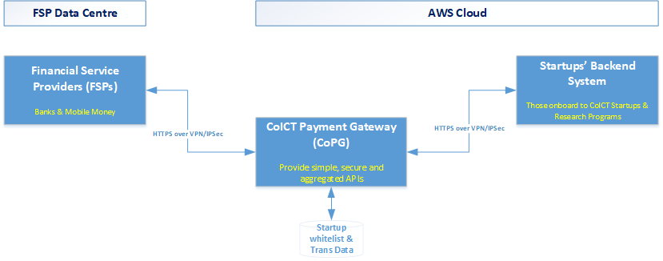

Figure : Logical Architecture

# Next steps

* Engage BOT to help understand any specific requirements for this gateway if any and them be informed and provide needed clearance
* Design and implementation of the solution
* Engaging with FSPs and perform integrations
* System integration tests and signoff
* Release API for consumers
* System integration tests with consumers
* User Acceptance tests for each consumer and signoff